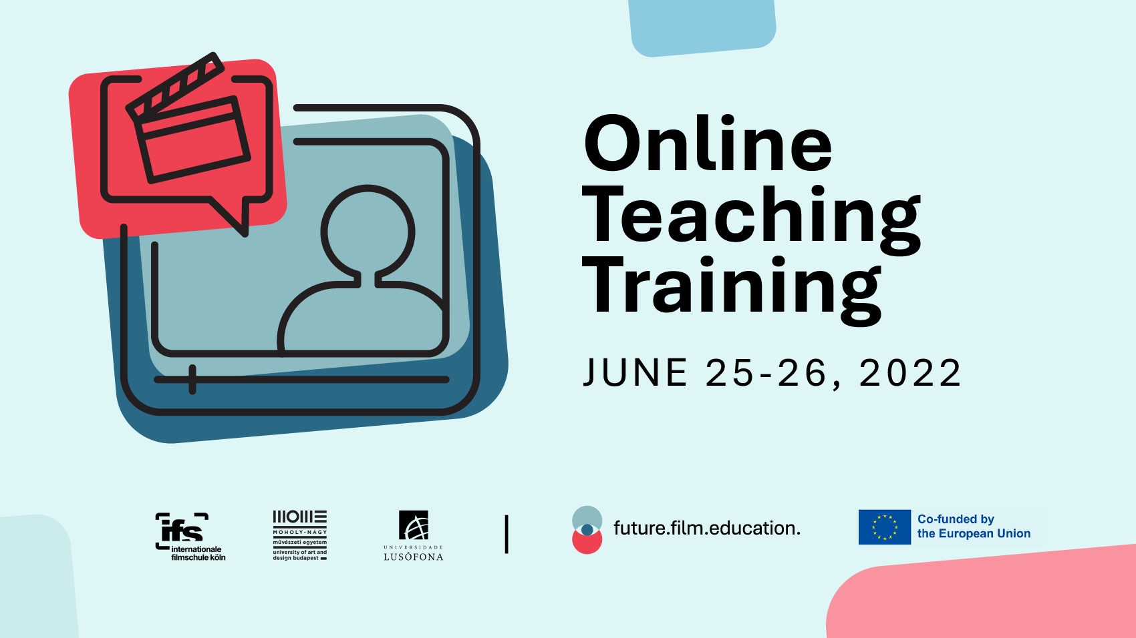
​Online Teaching Training

Are you a film or media arts teacher seeking for new approaches to teaching online?

future.film.education invites you to seize the opportunities of online teaching in our free online teaching training course.

In two days, you will have the chance to redesign your courses and prepare them for the online classroom. In a peer case review with other film and media arts teachers, you will acquire the fundamentals of e-learning and be able to share ideas and challenges.
Sign up to explore how you and your students can benefit from digital and online platforms. In this course you have the opportunity to sketch your own future online course(s). Please bring your course topics with you.
All you need is a microphone and a webcam. No special IT skills are required.
The workshop is free of charge and open to 40 participants.

June 25 – 26, 2022 (via Zoom)
(10:00-16:00h CEST incl. 1h lunch break)
Please register on our website: www.futurefilm.education

We will provide more information and the Zoom-link one week in advance.
If you have further questions, please ask our online trainer:
Dr. Eva Maria Bäcker | e.baecker@filmschule.de

about:
future.film.education is a collaborative research project aiming to contribute to a more innovative, inclusive and diverse film and higher education environment, both on- and offline.
The joint project brings together three European film and art schools, namely ifs internationale filmschule köln (DE), Moholy Nagy University of Art and Design (HU) and Universidade Lusófona (PT), to develop specialized toolkits and a MOOC for online teaching and diversity.

www.futurefilm.education

