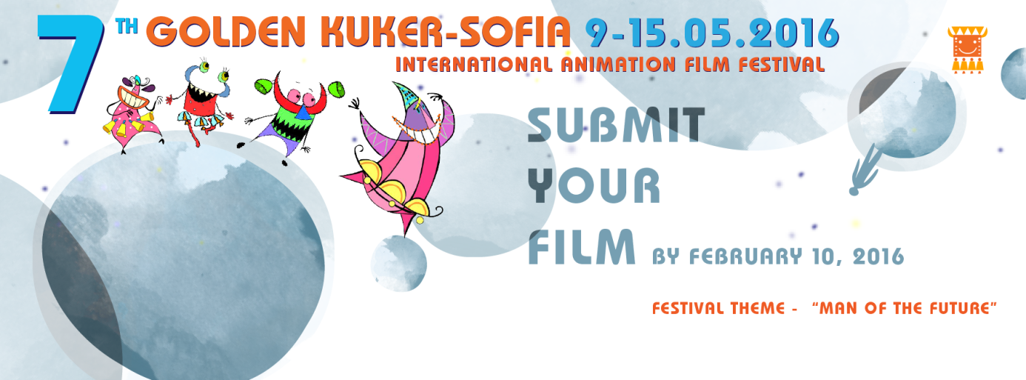
7th INTERNATIONAL ANIMATION FILM FESTIVAL GOLDEN KUKER – SOFIA, BULGARIA
9 - 15.05.2016
The International Animation Film Festival (IAFF) Golden Kuker- Sofia was run for the first time in October 2010 in Sofia. Named after Proyko Proykov (legendary Bulgarian animator) it is the first animation festival from the new century. One of the most attractive events in the arts calendar of Bulgaria takes place every spring in May. It is organised by the Bulgarian Association of The Independent Artists and Cartoon Animators an NGO chaired by Mrs. Nadezhda Slavova (cartoon artist, director, filmmaker and author of numerous animation films). The Association aims to connect animators, support their networking and create long lasting relationships within the cartoon industry.
The mission of the IAFF Golden Kuker-Sofia is to contribute to the development of Bulgarian art, to help Bulgarian and foreign animators get in touch and to support young professionals and students. The animation festival attracts not only children but large audience from different generations. IAFF Golden Kuker-Sofia has achieved high-level of professional performance, large number of international appearances, and variety of great animation works. Throughout the whole year people have the opportunity to attend master classes led by world known directors and animators, visit contemporary art seminars and exhibitions, and join interactive lectures. Environmental contest, Sofia’s children day and travelling festival are other festival’s post- events. After the festival international guests have the possibility to travel around Bulgaria, to discover wonderful spots and explore historical places with the tourist packages offered by IAFF Golden Kuker-Sofia.
Every year the festival has a special theme. The Jury awards two big prizes. The Grand Prix Golden Kuker presented to the best short or feature film and The Special prize Proyko Proykov awarded to the best film of the current year’s theme. IAFF Golden Kuker has been supported by the Ministry of Environment and Waters (Operational Programme Environment 2007-2013), Sofia Municipal Council, Sofia Municipality, National Culture Fund, National Film Center, Bulgarian National Television, Bulgarian National Radio, American Embassy, Czech Cultural Centre, Hungarian Cultural Centre, Polish Institute – Sofia, French Cultural Institute and many others who became our partners.
ONLINE ENTRY FORM
(deadline: 10 February 2016)
http://2016.animationfest-bg.eu/en/festival/register/
If you have any registration problems, please send us an email to film@animationfest-bg.eu

