Deutsche Welle Broadcasting Service to Collaborate With NAFTI
Published on : 05-Feb -2016 Source : NAFTI
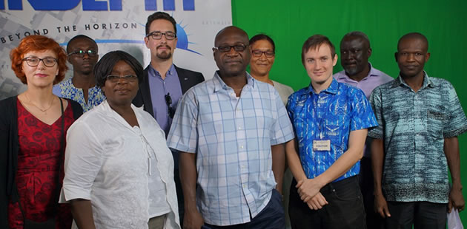Deutsche Welle (DW) broadcasting service, Germany’s state run international broadcaster, seeks to collaborate with the National Film and Television Institute (NAFTI) on its Broadcast Journalism Programme.
As part of preparations towards the collaboration, the Ghana Country Representative and the Ghana Country Coordinator of DW, paid a working visit to NAFTI on Wednesday, February 3, 2016 to familiarise themselves with the Institute’s facilities and faculty of the Institute’s Broadcast Journalism Programme.
The collaboration will see DW train NAFTI Broadcast Journalism lecturers, assist in the development of the Broadcast Journalism curriculum and provide support to the Institute in terms of its Broadcast Programme. This collaboration will cut across NAFTI’s Television, Radio and Online Broadcast Journalism Programme.
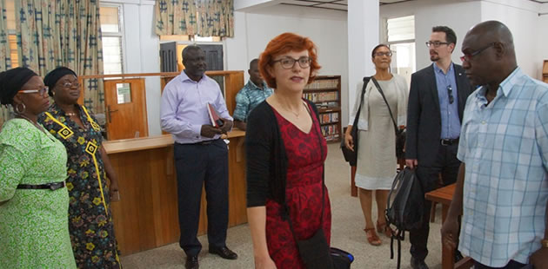
NAFTI currently runs a Broadcast Journalism Programme at the Certificate and Diploma Levels. The Institute has introduced a Bachelor of Fine Arts (BFA) Programme in Broadcast Journalism at the Degree Level to begin this academic year.

