NEW MEDIA FOR OLD: a reflection on how the past is present in the future.

Dear Colleagues,

In celebrating the hundredth anniversary of the establishment of VGIK, the most seminal moment in the history of film schools, we should remind ourselves that the work done here in the nineteen twenties and thirties still provides an important reference for the conception and realisation of all forms of filmmaking. It is a living legacy however sophisticated we imagine the craft has become.
I am reminded of this by the brief we have been given for contributions to the debate here in Moscow: ‘One of the fundamental problems in contemporary media communication is the under development of a quality storytelling taking into account the new media’s nonlinear heteromorphic interactive character.’ It is my contention that any development of new ways of telling stories should in part be based on referencing past work especially in relation to the application of technique. Crucially aesthetics and ethics, form and substance are two inseparable aspects of the whole, and this becomes even more true when the audience is encouraged to be an active rather than a passive spectator.
A few years ago my wife and I made a long desired trip to China. It turned out to be an unforgettable experience but it didn’t start well. We transited to Beijing via Singapore and on arrival we were looking forward to recovering in our hotel. The guide however was insistent that we go via the zoo to see the pandas at feeding time. Imagine our disappointment when we arrived at their enclosure to find they had already fed and had retired to their shelter among the rocks. Just as we were about to leave the guide spotted the emergence of a large male from his cave. He laboriously galumphed his way straight towards where we were stood. He paused – fixed us with a steely stare – then turned his back on us and performed a massive defecation into the gulley between him and the fence. With a satisfied but seemingly dismissive glance back at us he slowly returned to his lair.
Recounting a memory is a form of non-linear storytelling and although this anecdote is not heteromorphic it is certainly anthropomorphic. What it proves though is that the experience of interactivity is not always a positive one.
Non-linear is a convenient label for playing with time and space when the conception and realisation is usually concerned with no more than the next or previous plot point in whatever order the narrative is presented. e.g. Back to the Future
None of this new media is truly heteromorphic, i.e. occurring in different forms except in manipulation beyond the reality of human experience. e.g. Superman.
And so-called interactivity is usually an excuse for substituting motor responses for the intelligent elaboration of the human situation. e.g. the principle of gaming.
If any of these new dimensions to filmic storytelling are to be developed at a deeper formal or thematic level then the reference to past attempts at serious use of the medium can be an essential touchstone.
Returning to the legacy of early Soviet Cinema and the need to examine each ‘new’ development carefully rather than imagine it can immediately revolutionise the media I am reminded of the response to the arrival of synchronous sound in a statement signed by Sergei Eisenstein, Vsevolod Pudovkin and Grigori Alexandrov.
Their conclusion was that: the first experimental work with sound must be directed along the line of its distinct non-synchronisation with the visual images and only such an attack will give the necessary palpability which will later lead to the creation of an orchestral counterpoint of visual and aural images. This (as opposed to the photographing of plays), will lead to the greater possibility than ever before for the circulation throughout the world of a filmically expressed idea.
Sound as counter-point, rather than being a slave to image, created a dialectical montage and the delay in introducing synchronous sound in the Soviet Union arguably gave us a bonus of classic films at a time when Hollywood was struggling with stilted performances dictated by the requirements of primitive recording as satirised in Singin’ in the Rain.
In Japan, because the exponents of Benshi fought a rear guard action against the introduction of sound there was a similar delay to the introduction of synchronous sound. It would be worth studying whether there was a subsequent benefit especially as the art of the Benshi was an interactive part of the experience of viewing. By responding to the silent film in real time the Benshi became an intermediary between the audience and the drama on screen thus inviting the spectator to interact with character and situation.
The notion of ‘new’ media obfuscates the legitimate radical approaches to the use of the medium already explored by intelligent filmmakers in the past. The existence of new technological devices and applications doesn’t of itself suggest the de facto existence of new narrative forms. Perhaps a reminder of some of past explorations can put new media in a proper perspective and at the same time provide reference points for reconsideration of the teaching of filmmaking.
Sixty years ago the relief I sought from the sterility of studying social science at university was provided by seeing particular films by extraordinary filmmakers: Akira Kurosawa and Ingmar Bergman.
Kurosawa’s Rashomon (1950) took two short stories by Ryunosuka Akutagawa and in a low budget black and white film presented four versions of the same events in an exquisite and moving form that left the audience not just having to decide for themselves what really happened, but more importantly it reminded every viewer that absolute ‘truth’ is impossible to define and that the search for it should never obscure the tragedy of the event itself. Kurosawa’s decision to shoot the four witness statements from the same fixed position put the viewer literally in the judge’s seat. Whilst we as audience have no control over the action we are asked to interact with the multiple versions just as the motley group sheltering from the rainstorm under the great gate have to struggle to decide what to do with the abandoned baby.
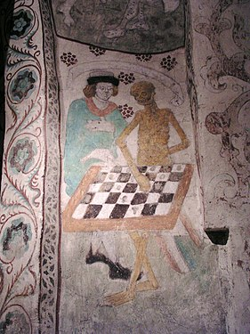Ingmar Bergman’s The Seventh Seal (1957), partly inspired by this 15th century painting by Albertus Pictor, is an example of how the experience of film can be interactive without there being any control over the outcome. The film asks us to engage with the Knights’ struggle with Death, during a protracted game of chess, the original interactive pastime, as he seeks to postpone the inevitable. It gives pause to us all in reviewing our own journey towards that end. In such a case any attempt to construct a narrative that has alternates would only deflect form the proper contemplation of that comparison. It is not a question of when we die but how we have lived. In the same year Bergman made Wild Strawberries which also contemplates the personal past and provokes a reconsideration of our own life. There is no present without a past and in that sense every breath we take is an interactive and non-linear action.
Also we might contemplate the decision of Robert Bresson to call his film A Man Escaped or: The Wind Bloweth Where it Listeth (1957), so stating categorically that he is not concerned with the question of whether the prisoner escapes or not. Another example of the insignificance of action compared with the examination of the nature of humanity. What happens should be the line on which we peg out our analysis on the human condition.
Given the means now available would Kurosawa, Bergman or Bresson have gained any significant depth or profundity from new techniques in non-linear, heteromorphic, interactivity?
The question is whether any of these new media has the potential to add anything to the filmic experience beyond another level of confection to the entertainment quotient beloved of producers, distributors and exhibitors.
Interactivity certainly worked in the Coliseum in Ancient Rome. After all what could be more immersive than shouting your response to the emperors question should the gladiator live or die? Thumbs up or down has been replaced by thumbs manipulated to decide the antagonist’s fate in a computer game. Technical flexibility is no match for the mental agility required in responding to the world - including whilst watching a filmic representation of real or imagined lives.
To support my argument that we should remember past experiments when considering future forms I want to cite Agnes Varda, whom we are mourning this year. I was present at her last appearance at the Cine Lumiere in London where she presented some sequences from her life’s work talking, in English, directly to the audience. Her passion finally got the better of her when, after a particularly moving segment, she took the mike again and lapsed into her mother tongue - speaking passionately in French.
When Agnes made her first full-length film La Pointe courte in 1955 she knew nothing about cinema. She said:
AV: I tried to avoid taking the easy way out, where you tell a story, you explain everything and then it’s over I’m more interested in trying to find something that forces me to find a new filmic language (cinecriture) that continually sets up new relationships between the person who envisions and creates the film and the person who sees it. The intellectual basis for the film was William Faulkner’s The Wild Palms.
It was Faulkner who managed to combine fifteen different narrators in his masterpiece, As I Lay Dying, but in this feverishly beautiful novel Faulkner interweaves two narratives, each wholly absorbing in its own right, each subtly illuminating the other. In New Orleans in 1937, a man and a woman embark on a headlong flight into the wilderness of illicit passion, fleeing her husband and the temptations of respectability. In Mississippi ten years earlier, a convict sets forth across a flooded river, risking his own chance at freedom to rescue a pregnant woman. The equivalent in Varda’s film is the contrast between life in a fishing community in Sete in southern France and the visit to the area by a couple whose relationship is fracturing.
AV: The narrative doesn’t flow smoothly because of the two parallel stories that are cut together arbitrarily. It could be seen as the clash between private life and social life, which can never be joined. It’s a contradiction that is inherent in our lives and that I think everyone understands.
Conventional dramatic presentation can tend to dissolve this distinction between private and public thus reducing the range and depth of creative expression. By skating along the surface new media is likely to encourage this reduction to the superficial. On the other hand developing narratives that hinge on situations that provoke revelations of the truth behind the masks of characters is a worthy aim of filmmakers.
AV: I tried to express it on film, calmly, abstractly. There are no dramatic events, (in contrast to Faulkner’s feverish narrative RC) just the juxtaposition of the two worlds and two ways of seeing the world. One is carefully crafted in terms of framing and dialogue, and the other is more like Italian neo-realism (though I’d never seen those films at that time).
Agnes couldn’t afford synchronous sound recording. Word for word notes were taken of the dialogue between the couple and they were post-recorded to match. The alienated couple was seen in mid or far distance – but their dialogue was recorded close-up and voiced dispassionately. This added a level of alienation and contrast with the treatment of the ‘real’ people in the fishing community. A lesson in how primitive technique can be a bonus. Even though necessity was the mother of invention I can’t help feeling that those Soviet filmmakers would have approved of her approach.
Despite everything that has been attempted over the past 100 years we have yet to fully explore the value of stepping outside of the conventional representation of reality in creating films that refresh our perception of life. Can new media be harnessed to further this important exploration of the inherent value of the form?
It is worth mentioning that Agnes Varda experimented with installation work towards the end of her career. In this she was joining a number of filmmakers who have found this form an interesting alternative more appropriate to their needs. Chantal Akerman, another wonderful filmmaker who is sorely missed, was a particularly interesting example who alternated between film and installation – even sometimes making a version in both forms. It is this choosing of the appropriate form rather than artificially incorporating ’new’ media that I find most interesting.
From La Pointe courte onwards Agnes never ceased to seek that ever more effective cine-criture as she called it. She made five short works before essaying her next feature Cleo de cinq a sept in 1962 which portrayed an anxious two hours in the life of a singer, Corinne Marchand, as she waits for cancer test results. Her use of sound is very sophisticated again. She was still freewheeling when she made Visages, Villages in 2017. This film is a series of episodes showing interaction between people and places. At one moment near the end she and her travelling companion, JR, the muralist, make the trip to visit Jean-Luc Godard having set up the rendez-vous at his house in Switzerland. Jean-Luc is not at home and even Agnes’ usual bonhomie is disturbed by his rudeness. In my opinion she need not have worried. History will eventually recognize that of the two she has been the more radical in exploring the form.
In this Agnes had an ally in Alain Resnais who was eventually persuaded by her to edit La Pointe courte: Originally he had turned her down because, he said, she was too interested in an approach to cinema similar to his own. He finally agreed after she promised to number all her footage by hand, a technique the digital generation would find hard to comprehend, and to guarantee a decent lunch break. When she frankly admitted her total ignorance of cinema history he dictated a list of films and filmmakers she must study and only then did she became a diligent student of cinema.
Resnais began by editing and then directed many shorts, including a number of encounters with artists already demonstrating an appetite to learn from other forms. This culminated in the excoriatingly disturbing and controversial documentary on the Nazi concentration camps, Nuit et Brouillard (1957). However it was Resnais’ first feature that finally established him as a serious explorer of the form: Hiroshima mon amour (1959). Having travelled to Japan to make a film Resnais lost faith in the concept of a documentary on the bombing of Hiroshima, but having made the trip was loath to abandon the project. He established a writing arrangement with Marguerite Duras and the film is based on the script they developed. Duras had already become a leader of the nouveau roman movement that was happy to embrace multiple perspectives and a conflation of past, present and future in different locales. So Hiroshima and Nevers in France coalesce through the character of ‘her’ played exquisitely by Emmanuelle Riva in a passing relationship with ‘him’ played by Eiji Okada.
Arguably it is a film that uses the three aspects of new media we are concerned with being artfully non-linear, centrally concerned with heterogeneity and interactive on many levels within its own narrative form. At the time the film provoked an extended debate published in Cahiers du Cinema which is well worth quoting from:
Pierre Kast: We are at the very core of a reflection on the narrative form itself. The passage from the present to the past; the persistence of the past in the present, are no longer determined by the subject, the plot, but by pure lyrical movements.
And Jacques Rivette: The problems that Resnais sets himself in film are parallel to those that Stravinsky set himself in music. What does it mean? The search for an equilibrium superior to all the elements of creativity.
And Eric Rohmer: Hiroshima is a film that plunges at the same time into the past, the present and the future. It has a very strong sense of the future, particularly the anguish of the future.
Significantly all agree in this debate that Resnais had applied and significantly deepened the use of montage first defined and applied by Eisenstein. Resnais and Duras provide a response to the deliberate destruction of humanity by use of the atom bomb, by using a similarly sophisticated intercutting of private and public, past and present, across continents and time to confront the very basis of ethics without resorting to polemic.
In his subsequent films, Resnais was often inspired by meeting and working with other explorers of form. From Alain Robbe Grillet (L’annee dernier a Marienbad) To Jean Cayrol (Muriel) to Jacques Semprun ( La Guerre est fini and Stavisky.) On the face of it his most surprising source of material was the work of the English playwright Alan Ackbourn that persistent satiriser of the English middle classes. Resnais transposed three of Ackbourn’s plays to film.
Resnais said: How did it all begin? I had read in a magazine that the very prolific Mr. Ayckbourn was putting on his plays in the little seaside resort of Scarborough, in a theatre in which the audience itself served as the three walls. Sabine (Mamou his wife) and I went up there as if on a safari deep into an exotic jungle. A few years later I saw Sabine laughing to herself reading a huge Ayckbourn play entitled Intimate Exchanges, which only used two actors to play a multitude of characters, but you had to go to the theatre twelve times to see the entire play!
He decided to make two versions as a film – called Smoking/No Smoking – a reference to the fact that in all versions a woman’s decision whether to have a cigarette is the first choice made and as the script develops the choices become ever more significant and life-changing.
The options are illustrated in this chart:
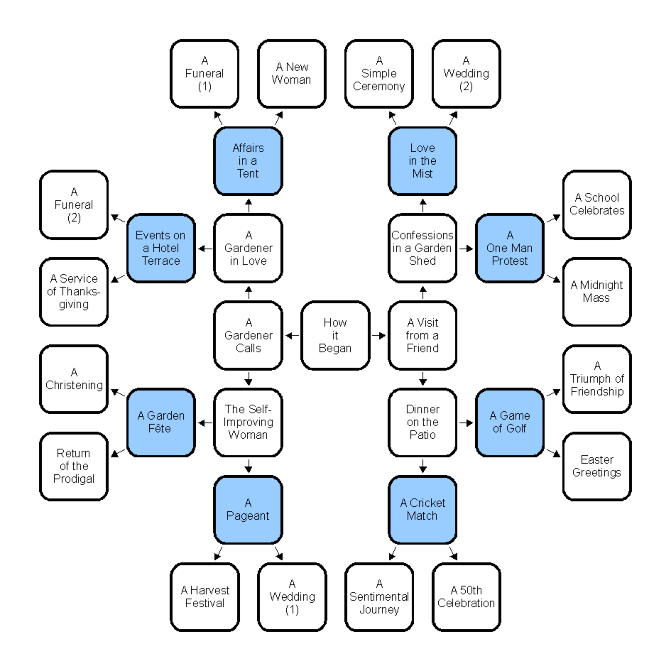

Resnais summarised his approach thus: I try hard to give rhythm to the changes of pace in a film, so that the directing is full of contrast: moments when the direction is reserved and academic, and then suddenly there’s a change in tone. I say it for all my films: what interests me is form, and if there’s no form, there’s no emotion. I still get a kick out of bringing together things that shouldn’t meet. It’s that I call the attraction of danger, of the abyss.
This seems to me exactly what Jacques Rivette was alluding to in talking about Stravinsky’s exploration in music. Most significantly we should recognise that writers and composers still have much to teach us in searching for different ways to construct narratives and apply ‘new’ media.
Paraphrasing a paragraph in my article in the CILECT book The 21st century Film, TV and Media SchooI:
We do not have the tabula rasa that allowed Kuleshov and Eisenstein to create an approach to filmmaking without needing to wipe the slate clean of existing conventions. In this new century we are faced with an almost infinite array of forms along with an ever increasing range of devices for viewing what we create. Perhaps it is that very chaos that represents an opportunity to use our schools to reevaluate the options through which the new generation, whose learning we facilitate, will use the form, to offer stimulating and positive experiences on screens large and small in the future.
Effective and serious application of new media will always benefit from reference to the past and not only past cinema to all relevant creative expression, whether it be literature, music, painting or poetry.
Resnais said:
A classic film cannot translate the real rhythm of modern life. In the same day, you do twenty-six things, you go to lectures, to the cinema, to your party meeting etc. Modern life is fragmented. Everybody feels that; painting, as well as literature bears witness to it, so why should the cinema not do likewise, instead of keeping to the traditional linear construction?
It is in this spirit and with such seriousness that we should approach the consideration and application of new media.

PERSONAL POSTSCRIPT:
I imagine this will be my last contribution to a CILECT debate so I would like to end by quoting two writers whose sentiments sum up my feelings.

Robert Frost’s poem The Road not Taken begins:
Two roads diverged in a yellow wood,
And sorry I could not travel both
And be one traveller, long I stood
And looked down one as far as I could
To where it bent in the undergrowth;
…..
and ends:

I shall be telling this with a sigh
Somewhere ages and ages hence:
Two roads diverged in a wood, and I—
I took the one less travelled by,
And that has made all the difference.

I am happy to end not with a whimper but with a sigh.

Were I a writer I would allow only my heart to have imagination
and for the rest rely upon memory: that long-drawn sunset shadow of our personal truth

Vladimir Nabokov

Roger Crittenden, England, August 2019
rcrittenden@nfts.co.uk

