CALL FOR PROJECTS

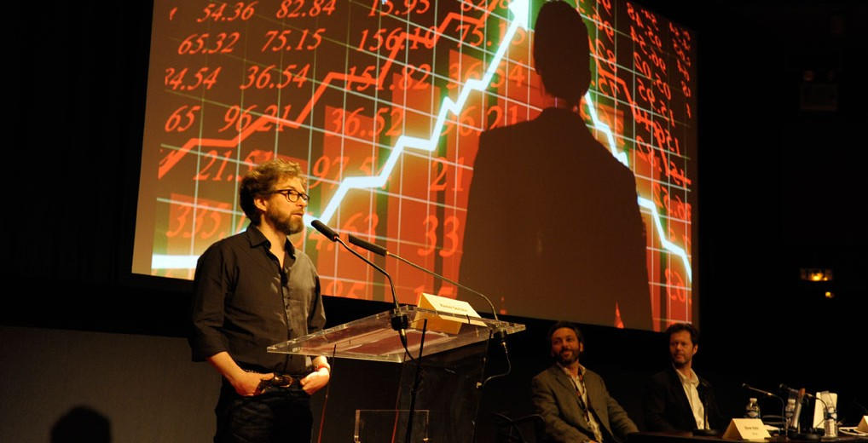

**Call for European Coproduction Forum 2016 projects**

**THE CALL FOR PROJECTS IS NOW OPEN!**

 You can now register your project to the pre-selection of the 2016 **Series Mania European Co-production Forum** *(lien vers page presentation*European Coproduction Forum).

  To register your project you must complete the **online form** below before **Friday, February 26, 2016.**

Please note that in order to validate the form, you must upload the following elements:

* a 5 pages presentation of the project
* a provisional production planning
* a financing plan
* some photos of the projects (if available)
* a cover letter

The selection results will be communicated by e-mail in **March 2016.**

For any questions please contact:[forumcopro@forumdesimages.fr](mailto:forumcopro@forumdesimages.fr) or call **+33 (0) 1 44 76 63 20.**